Project Design Phase
Solution Architecture

Date | 15 February 2025
Team ID
Project Name | Auto Ticket Classification using Flow Designer
Maximum Marks | 4 Marks

Solution Architecture:
Solution architecture is a complex process – with many sub-processes – that bridges the gap between business problems and technology solutions. Its goals are to:
- Find the best tech solution to solve existing business problems.
- Describe the structure, characteristics, behavior, and other aspects of the software to project stakeholders.
- Define features, development phases, and solution requirements.
- Provide specifications according to which the solution is defined, managed, and delivered.

Solution Architecture Diagram:

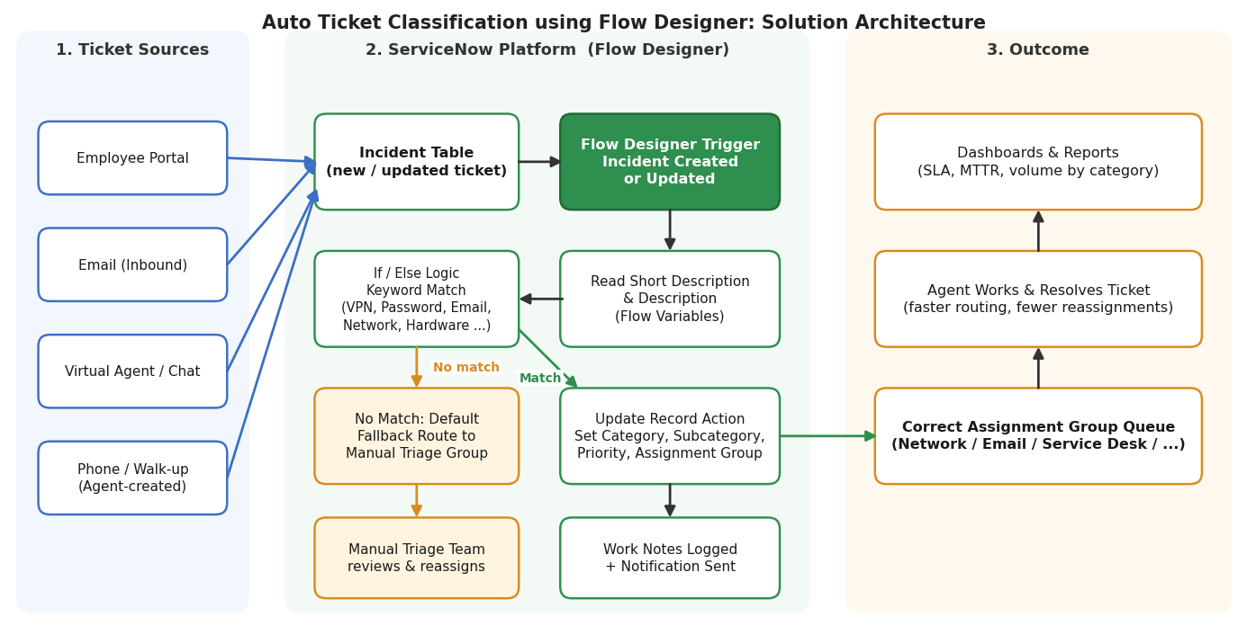
Figure 1: Architecture and data flow of Auto Ticket Classification using Flow Designer
Components and Data Flow:
The solution adds a Flow Designer flow on top of the existing ServiceNow incident process. When a ticket arrives, the flow reads its text, applies the keyword rules, updates the classification fields and routes the ticket to the correct team, and unmatched tickets go to manual triage.
S.No. | Component | Description
1 | Ticket Sources | Employees raise incidents through the portal, inbound email, virtual agent chat, or agents log them from phone calls and walk-ups.
2 | Incident Table | Every new or updated ticket is stored in the ServiceNow incident table, which starts the automation.
3 | Flow Designer Trigger | The flow runs automatically when an incident is created or updated, with no manual step.
4 | Read Ticket Text | The flow reads the short description and description into flow variables for matching.
5 | If / Else Keyword Logic | Conditions check for keywords such as VPN, password, email, network and hardware to decide the correct class of ticket.
6 | Update Record Action | On a match, the flow sets the category, subcategory, priority and assignment group on the incident.
7 | Fallback Route | If nothing matches, the ticket goes to a default triage group where the manual triage team reviews and reassigns it.
8 | Work Notes and Notification | The flow writes what it did into the work notes and notifies the assigned group.
9 | Assignment Group Queue | The right team sees the ticket in its queue and an agent works on it and resolves it.
10 | Dashboards and Reports | Reports track SLA compliance, mean time to resolve and ticket volume by category.

Reference: https://docs.servicenow.com

